

How to play chess

The players sit facing each other with a white square of the board at each player’s right. The diagram shows how the pieces are placed at the beginning.

How the pieces move and capture

The player who conducts the white pieces known simply as “White” always makes the first move “Black” responds and the game continues with the players moving alternately. Only one piece may be moved at each turn, except for castling which involves two pieces.

To capture, you move your piece to a square occupied by one of your opponent’s pieces. The opponent’s piece is then removed from the board. In chess you do not have to capture a piece just because it is possible to do so. You may never move a piece to a square already occupied by one of your own pieces.

KING
The king can move or capture one square in any direction.

QUEEN
The queen can move or capture any number of squares horizontally, vertically, or diagonally if the path is obstructed.

THE ROOK
The rook can move or capture any number of squares vertically or horizontally if the path is unobstructed.

BISHOP
The bishop can move or capture diagonally any number of squares in either direction if the path is unobstructed.

KNIGHT
The knight moves in the ‘L’ pattern indicated. The knight is the only piece that my jump over other pieces. Note that the knight always moves from a dark square to a light square or vice-versa.

PAWN
The pawn moves only straight ahead (never backward), but captures diagonally. The moves are illustrated by arrows; captures by ‘x’. When a pawn is in its starting position, it may advance one or two squares the first time it moves. After that, it may advance only one square per move. If a pawn advances all the way to the opposite side of the board it must be promoted to another piece (except a king) of the same colour, usually a queen. This means that it is possible to have more than one queen or more than two rooks, knights or bishops per player on the board.
To capture ‘en passant’: when your opponent moves a pawn two squares on its initial move and your pawn sits beside it, you may move your pawn to the square over which your opponent’s pawn has just moved, and remove your opponent’s pawn from the board. This option may be exercised on the very next move only. Another way of looking at it is that you may capture an opponent’s pawn that has just made a two square initial move as if it had only made a one square move.

Castling
To castle, move your king two squares either right or left, and then place your rook on that side of the board on the square over which the king passed. Castling is only possible when: no piece stands between the king and rook;
the king is not in check; neither the king nor the rook has moved before in the game; and the king does not pass through a square under attack.

Long ( 0-0-0 )

CASTLING

Short ( 0-0 )

Check
Any move that attacks the king is called a ‘check’. The object of chess is to attack the opponent’s king in such a way that no matter how he replies, his king will still be under attack. This is called ‘checkmate’ and wins the game. Your own king must not be in check after you have moved. Therefore, you must remove any check your opponent makes against your king.

Stalemate
If a player, to move, is not in check, but has no legal move - a kind of checkmate without the check - the game is a draw. Neither player wins. This is called stalemate. Another way to get a draw is if there isn’t enough material on the board to force a checkmate. For example, put a knight, a white king, and a black king on the board. There is not checkmate possible, the game is a draw.

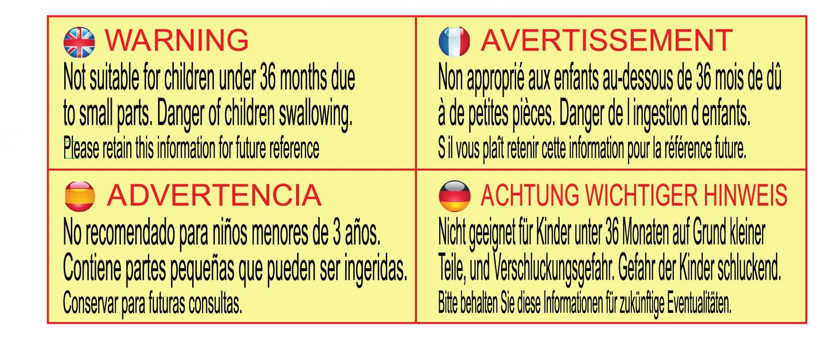

www.traditionalgardengames.co.uk

